TRAFFIC ACCIDENT SEVERITY PREDICTION SYSTEM

Project Id: 20

Name : PRIYANI SINGH (Team Leader)
Class Roll Number:5
University Roll Number : 2028806
Section and Group: P and G2

Name : SUDITI VERMA
Class Roll Number: 70
University Roll Number : 2028868
Section and Group: P and G2

- Problem Description 3
- Architecture 4
- Models model 5
- Evaluation metrics used 6
- Preliminary Results and Visualizations 7-10
- References 11

PROBLEM DESCRIPTION

Traffic accidents are a major global issue, causing significant loss of life and property. Predicting accident severity in advance can help authorities take preventive measures, optimize emergency response, and improve road safety.
This project aims to build a machine learning-based classification system that predicts the severity of traffic accidents based on various factors such as:
- Number of vehicles involved
- Environmental conditions
- Other accident-related features
The system follows a complete ML pipeline:
- Data preprocessing
- Exploratory Data Analysis (EDA)
- Feature engineering
- Model training and evaluation
The problem is formulated as a multi-class classification task, where accident severity is categorized into:
- Low
- Medium
- High
To improve prediction performance, techniques like feature scaling, class balancing (SMOTE), cross-validation, and hyperparameter tuning are applied.
The goal is to identify the most accurate and reliable model for predicting severe accidents.

ARCHITECTURE

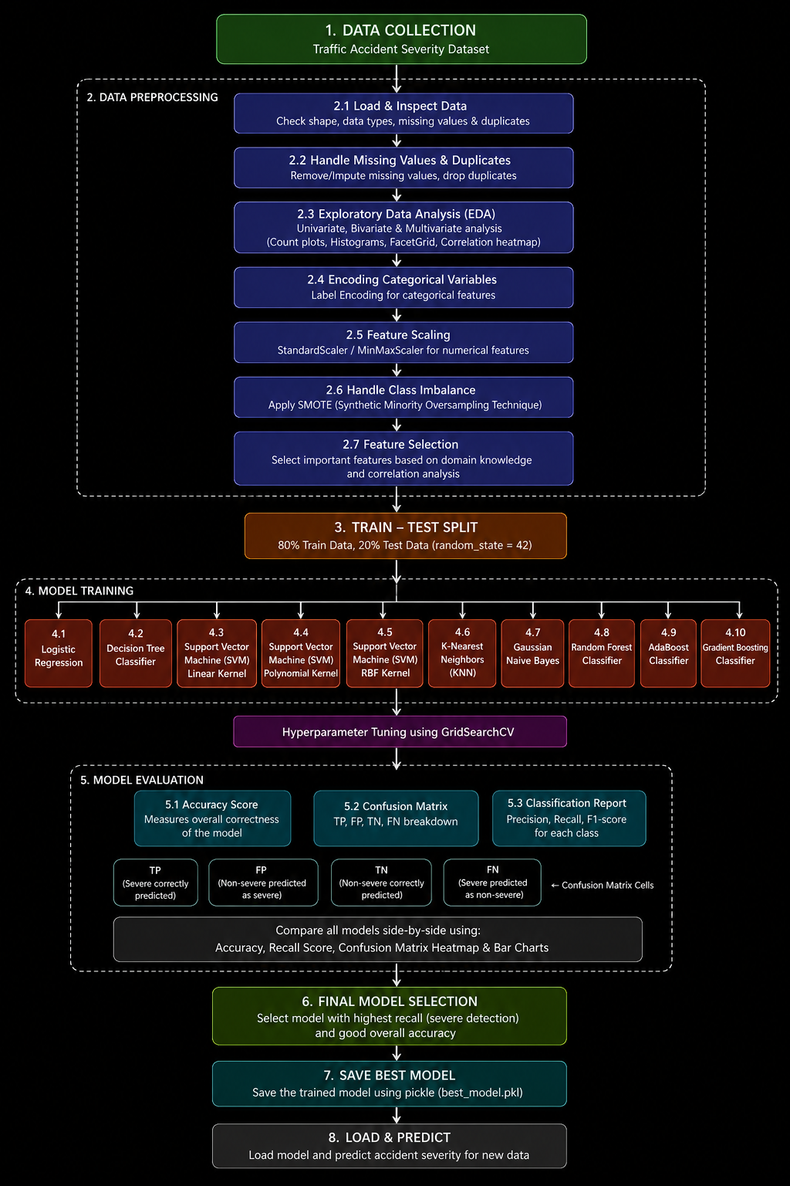

MODELS USED(APPLIED/ PLANNED)

- Logistic regression
Despite its name, Logistic Regression is a classification algorithm, not a regression one. It learns the probability that an email belongs to the spam class by fitting a sigmoid (S-shaped) curve to the word-count features. It draws a single straight decision boundary between spam and ham in the feature space — simple, fast, and highly interpretable.
Kernel / boundary Linear (sigmoidfunction)
Training speed Very fast
Interpretability High — feature weights are readable
Best for Linearly separable text data
- SVM — Linear kernel
A Support Vector Machine finds the hyperplane that best separates spam from ham with the maximum margin — meaning it pushes the decision boundary as far as possible from both classes. The linear kernel works directly in the original word-count feature space, making it extremely effective for high-dimensional text data like bag-of-words vectors.
Kernel Linear
Decision boundary Straight hyperplane
Works well when Data is linearly separable
Training speed Moderate

- SVM — Polynomial kernel
The polynomial kernel allows SVM to learn curved, non-linear decision boundaries
by implicitly mapping the input features into a higher-dimensional polynomial space.
With degree=3 (cubic), it can capture interactions between words — for example, the
combination of "click", "free", and "now" being stronger spam signals together than
individually.
Kernel Polynomial (degree = 3)
Decision boundary Curved (cubic)
Captures Word combination patterns
Training speed Slower than linear

- SVM — RBF kernel
The Radial Basis Function (RBF) kernel is the most powerful and flexible SVM variant.
It measures similarity between data points using a Gaussian bell-curve function,
allowing it to capture complex, non-linear patterns. It can wrap decision boundaries
around clusters of spam words in any shape — making it suitable even when spam and
ham patterns are not easily separated by lines or curves.
Kernel RBF (Gaussian)
Decision boundary Highly flexible / non-linear
Captures Complex feature clusters
Training speed Slowest of the four

- Decision Tree Classifier
A tree-based model that splits data based on feature conditions.
- Decision Boundary: Non-linear
- Advantage: Easy to understand
- Limitation: Can overfit

6.Naive Bayes (GaussianNB)
Based on probability and Bayes theorem.
- Fast and efficient
- Assumes feature independence

7. AdaBoost
Boosting algorithm that improves weak learners.
- Focuses on misclassified points
- Improves performance iteratively

8. Gradient Boosting
Advanced boosting technique.
- High predictive power
- Works well on complex datasets

9. Random Forest
Ensemble of multiple decision trees.
- High accuracy
- Reduces overfitting

EVALUATION METRICS USED

1. Accuracy Score
- Measures overall correctness of predictions
2. Recall Score
- Measures ability to detect severe accidents
- Most important metric in this project
3. Confusion Matrix
Provides detailed classification results:
- True Positive (TP): Severe accidents correctly predicted
- True Negative (TN): Non-severe correctly predicted
- False Positive (FP): Non-severe predicted as severe
- False Negative (FN): Severe missed (critical error)

PRELIMINARY RESULTS AND VISUALIZATIONS

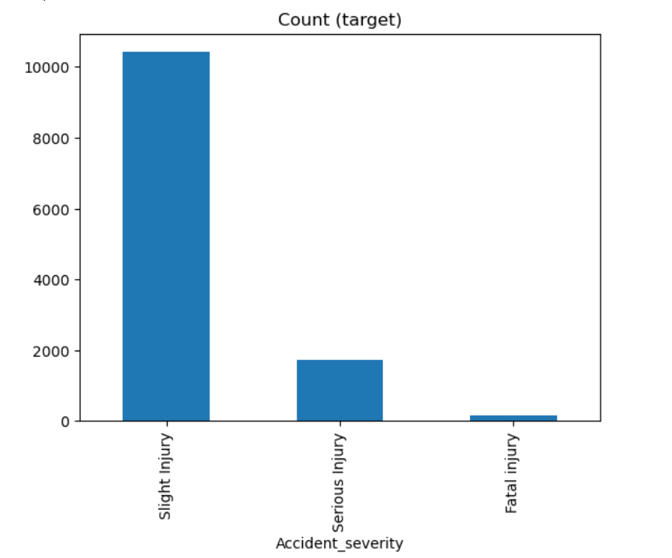

Fig 1. Shows imbalance in accident severity

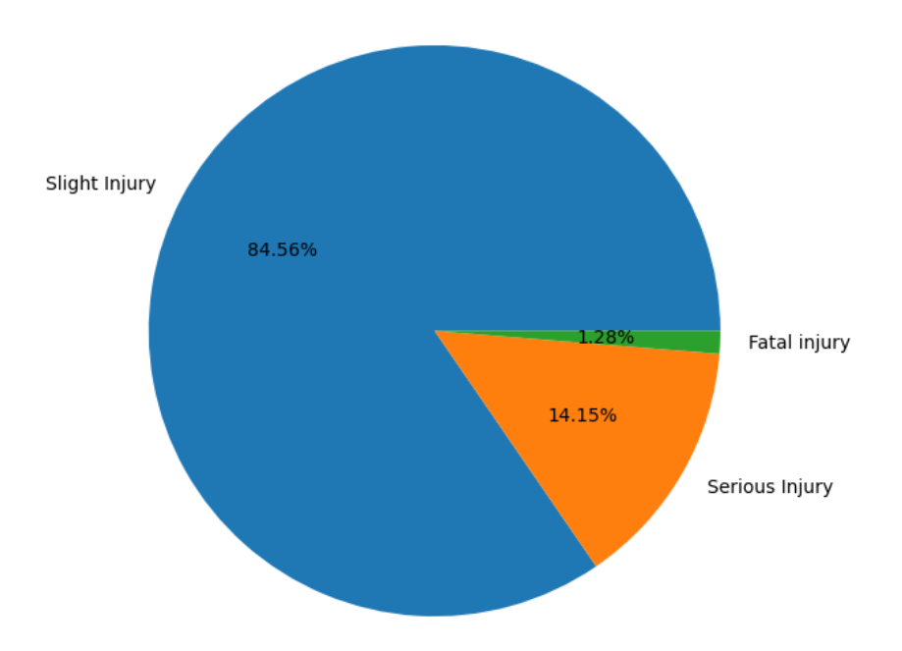
Fig 2. Pie chart of imbalance in accident severity

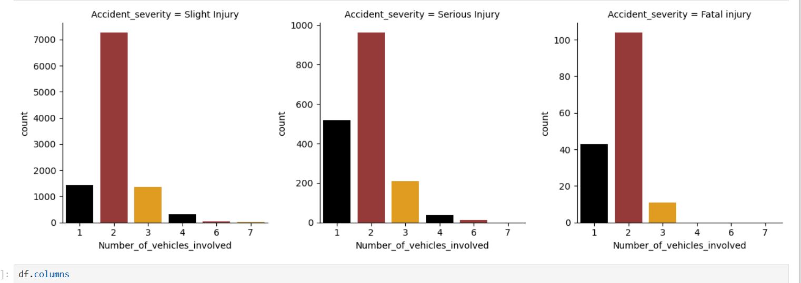

Fig 3. Feature-wise Analysis (FacetGrid)

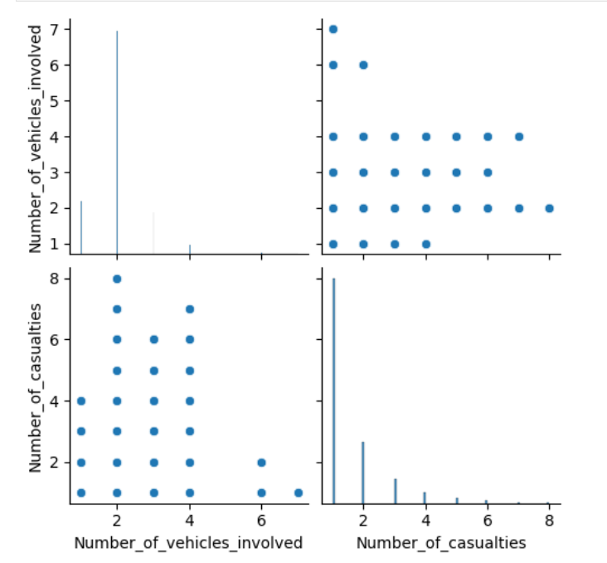

Fig 4. group analysis
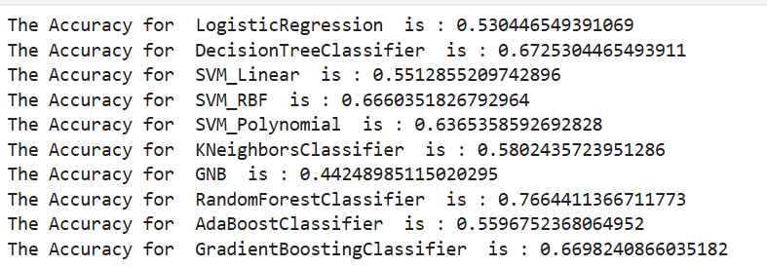
Fig 5. accuracy of all models

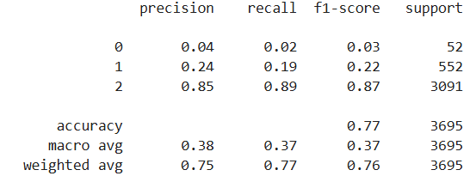

Fig 6. Confusion matrix of best model

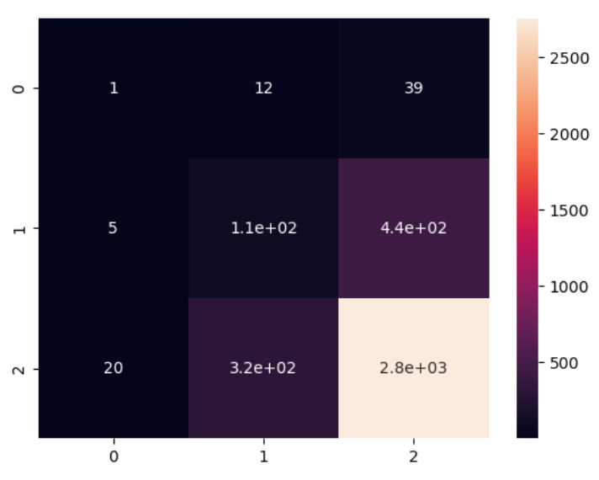
Fig 6. Heatmap of best model

REFERENCES
Books:
- Artificial intelligence and machine learning – S. CHAND

Online Resources:
https://scikitlearn.org/stable/modules/generated/sklearn.feature_extraction.text.CountVectorizer.html
https://www.geeksforgeeks.org/bag-of-words-bow-model-in-nlp/

